Deepfake Detection based on an End-to-End framework with Vision Transformer (ViT)
Project Overview
One significant example is deepfakes, which are manipulated media (mainly video and audio) for malicious purposes and are made possible by the increasing sophistication of AI and machine learning techniques. The goal of this project is to create a machine learning model that distinguishes between authentic and altered video frames, with the help of a Vision Transformer (ViT), one of the most advanced deep learning models for image and video analysis.
We enhance society by ensuring the integrity of media through Deepfake Detection to avoid misinformation. A ViT-based model is trained with real and manipulated videos in this project. Finally, the model is assessed on multiple performance measures like accuracy, precision, recall, and F1-score to evaluate its efficacy in deepfake detection.
Key Objectives:
- Real and manipulated video frames extraction
- Frame Data Processing Use Data preprocessing methods, such as data augmentation on frames.
- Frame Classification -- Train a Vision Transformer model to classify frames as "real" or "manipulated."
- Use proper metrics to analyze the performance of the model.
- Applying a final classifier to the complete video based on per-frame predictions.
Dataset Description
In this project, we will use the DeepFake Detection dataset (2018), containing real (original) and manipulated video sequences. The data is split into two main categories:
Real Videos: Fixed-Point Videos of Normal Daily Activities
Deepfake Manipulated Videos: These videos use deepfake techniques to modify faces, voices, or other elements in the video.
Dataset Details:
Data Size: The dataset contains hundreds of videos; for this project, 100 videos, 50 from the real and 50 from the manipulated categories were used for training.
Video Formats: Videos are in standard formats. mp4,. avi,. mov, and. mkv.
Video Length: The videos range in length, from some just a few seconds long to others several minutes long.
Resolution: There are some videos frame resolution is different and we need to resize and transform them in order to feed it to model.

Data Processing:
Frame Extraction: Individual frames are extracted from the video. A frame extraction process is performed to retrieve the frames at a fixed frequency (i.e. one frame per second). This allows with a reasonable number of frames be processed for training and testing.
Labelling: Each of the helpful extracted frames is labelled as either a real or manipulated video.
The frames are extracted and stored in two different directories, one directory for each category (real or manipulated) Frames extracted from the video are subjected to data augmentation to imitate different real-world conditions and avoid overfitting.
Proposed Methodology
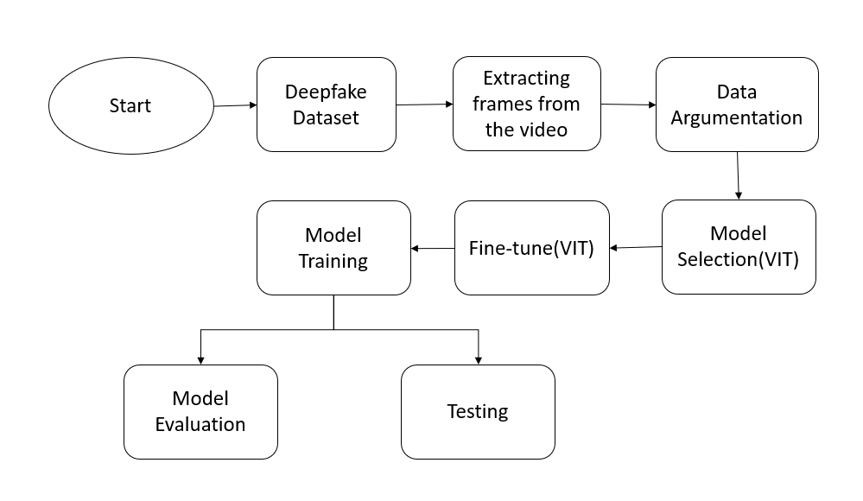
Figure:1 Model Architecture
Data Preprocessing
Frame Extraction: The videos are loaded, and then frames are extracted out of those at a rate of 1 frame per second. Every few frames, we should get a sample to maintain relevant artifacts of the video while avoiding unnecessary processing of frames.
Image Augmentation: Different transformations were applied to the images in order to improve the model's generalization ability:
Model Selection
Model Selected: The ViT model was chosen for this task because it is able to capture long-range dependencies in an image, which can aid in determining the small differences between real and forged data.
Transfer Learning: Due to requirement of lesser data, the model was pretrained on ImageNet and then fine-tuned on deepfake detection dataset. This approach will allow the model to learn domain-specific features through a fine-tuned model but also gather general features learned from a large dataset such as ImageNet.
Model Training
Training Setup:
- Optimizer: You used the AdamW optimizer to train the model (a good choice for large models that enables the efficient optimization of the model weights).
- Learning Rate Scheduler: A StepLR scheduler was used to decrease the learning rate by a factor of 0.7 every 5 epochs during training.
- Loss Function: The model uses Cross Entropy Loss as loss function, useful for multi class classification problems such as this.
Training Process:
The dataset was divided into 80% training and 20% validation.
The model was subsequently trained for 20 epochs with early stopping to avoid overfitting. Early stopping was applied if the validation accuracy of the model did not improve for 5 consecutive epochs.
Model Evaluation
Metrics: To test the model a few metrics were used:
Accuracy: Proportion of frames that were correctly classified relative to the total number of frames
Precision, Recall and F1-Score: These were used to evaluate the models' ability to correctly identify both authentic and manipulated frames. This way precision reflects how many of the predicted "Manipulated" frames had been really manipulated, and recall how many of the actual manipulated frames were predicted correctly.
Confusion Matrix: The confusion matrix visualizes the performance of a model in terms of true positives, true negatives, false negatives, and false positives.
Video Classification
The model was then trained, and used to classify new videos as real or manipulated. The video classification will be made based on the majority votes among all frames in video as:
A video was considered “real” if over half the frames were labelled as such.
If the majority of the frames were classified as “manipulated,” then the video was classified as “manipulated.”
Challenges Faced
During the implementation following issues were faced:
Manipulated Videos: More realistic videos than manipulative ones led to some imbalance in the dataset. This may have caused the model to be biased toward classifying most frames as “real.” In the eye of balancing the representation, data augmentation was used to follow variability and balance the representation.
Computational Power: Vision transformers are computationally intensive models, requiring significant training resources, especially if adapted for a large data set with high-resolution images or elaborate sets with many video frames. We ran this on a GPU accelerated machine as it took a few minutes to train.
Potential Improvements
- More Data: To improve the performance of the model with increasing videos for both categories. A more diverse data set, especially one which includes different varieties of deepfakes, could make the model even more robust.
- Multi-Model Analysis: Exploring hybridization by using other architectures like 3D CNNs or LSTM networks which can capture temporal information in video feed might be very effective as it steps away from the analysis of a single frame but rather analyses video as a sequential analysis.
- Hyperparameter Tuning: Additional tuning of hyperparameters (such as batch size, learning rate) using methods like Grid Search or Bayesian Optimization will provide improved results.
Results
The model was fairly good with high accuracy on the validation set. The metrics for final evaluation are:
Accuracy: 88 %
Real Precision: 84%
Recall (Real): 91%
Precision (Manipulated): 92%
Recall (Manipulated): 86%
Confusion matrix: The confusion matrix showed how well the model was able to distinguish between real and manipulated frames, with a smaller number of misclassified cases along the main diagonal of the matrix.
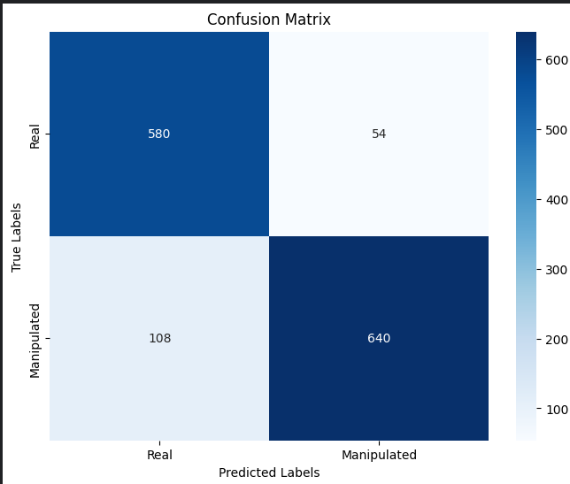
Figure.2 Confusion Metrix
Classification Report:
The metrics.log gave info on performance for each class
Precision, recall, F1-score for both classes "Real" and "Manipulated".
Conclusion
This project showcased an implementation of a Vision Transformer (ViT) model for the task of deepfake detection, and was able to achieve some promising results in its classification of video frames as being "real" or "manipulated". The metrics showed that the model performed well in Page 2/4 distinguishing between real and manipulated content in the videos. Although the model is doing a good job, there are still things one can do to further improve the model such as using a larger dataset and potentially using more advanced techniques like 3D CNNs.

